**Assignment - 4**

Kubernetes and Docker

|  |  |
| --- | --- |
| Assignment Date | 02 November 2022 |
| Student Name | Keerthana G |
| Student Roll Number | 2116190801086 |
| Maximum Marks | 2 Marks |

**Question-1:**

Pull an Image from docker hub and run it in docker playground.

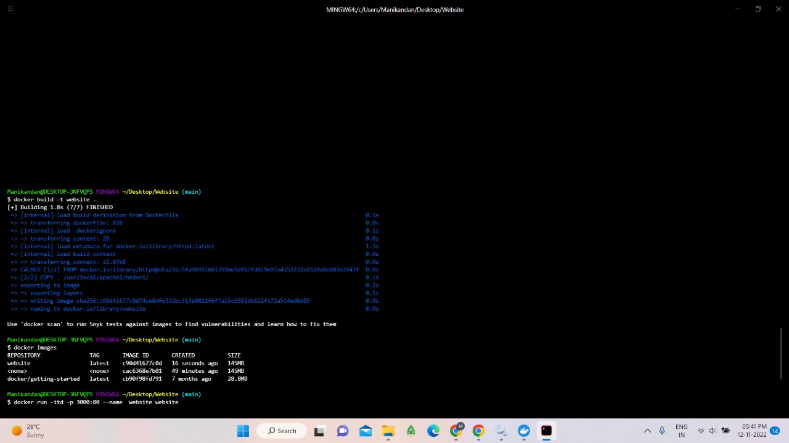

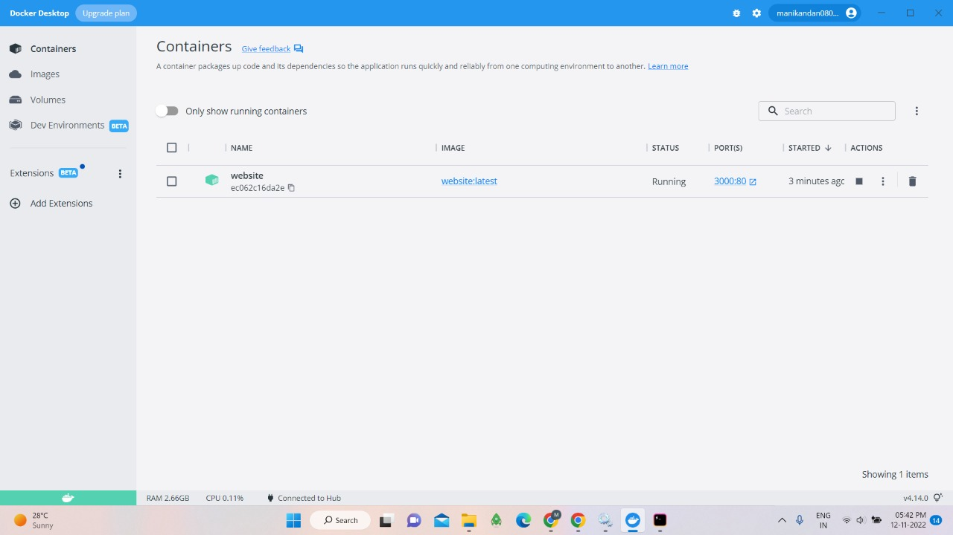

**Question-2:**

Create a docker file for the jobportal application and deploy it in Docker desktop application.

